Pericope: | Word Study (5 words) use studylight.org: “Lexicon”
3 Questions or Initial Thoughts
1. _______________________________________________  ________________________________________________  ________________________________________________  ________________________________________________  ________________________________________________  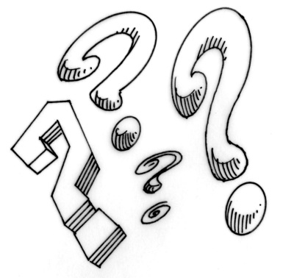  2. ______________________________________________  ________________________________________________  ________________________________________________  ________________________________________________  3. ______________________________________________  ________________________________________________  ________________________________________________  ________________________________________________ | 1. ________________________________________________  ________________________________________________  ________________________________________________  2. ________________________________________________  ________________________________________________  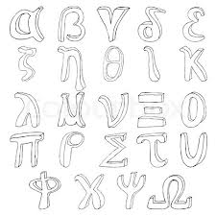  ________________________________________________  3. ________________________________________________  ________________________________________________  ________________________________________________  4. ________________________________________________  ________________________________________________  ________________________________________________  5. ________________________________________________ ________________________________________________
3 Translation Comparisons(highlight variations in grammar)  bible.cc “translation comparison” | Theological Analysis (teachings, problems addressed, connections to rest of scripture) wlsessays.net
1.________________________________________________  ________________________________________________  ________________________________________________  ________________________________________________  ________________________________________________  ________________________________________________  2. _______________________________________________  ________________________________________________  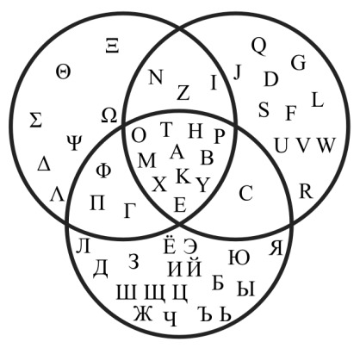  ________________________________________________  ________________________________________________  ________________________________________________  3. _______________________________________________  ________________________________________________  ________________________________________________  ________________________________________________  ________________________________________________ | 1.________________________________________________  ________________________________________________  ________________________________________________  ________________________________________________  ________________________________________________  ________________________________________________  2. _______________________________________________  ________________________________________________  ________________________________________________  ________________________________________________  ________________________________________________  3. _______________________________________________  ________________________________________________  ________________________________________________  ________________________________________________  ________________________________________________
3 Historical-Cultural Points (cite source) | Christocentric Analysis (Symbols, prophecies, archetypes, and events connected to Jesus)
1.________________________________________________  ________________________________________________  ________________________________________________  ________________________________________________  ________________________________________________  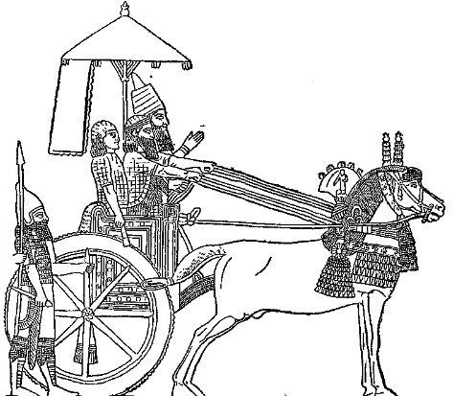  ________________________________________________  2.________________________________________________  ________________________________________________  ________________________________________________  ________________________________________________  ________________________________________________  ________________________________________________  3.________________________________________________  ________________________________________________  ________________________________________________  ________________________________________________ | 1.________________________________________________  ________________________________________________  ________________________________________________  ________________________________________________  ________________________________________________  ________________________________________________  2.________________________________________________  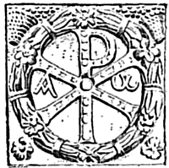  ________________________________________________  ________________________________________________  ________________________________________________  ________________________________________________  ________________________________________________  3.________________________________________________  ________________________________________________  ________________________________________________  ________________________________________________
Structural Analysis (immediate context) | 3 Commentary points
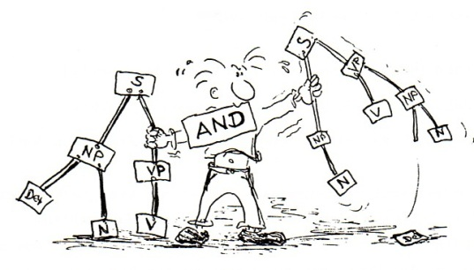
Trinitarian Analysis (describe the interaction of Father, Son, and Spirit)
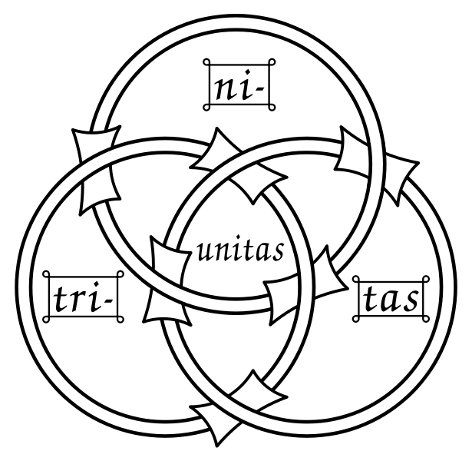
Father:

Son:

Holy Spirit:
Prayer (Use your data to write back to God! Tell Him your concerns throughout the week)

